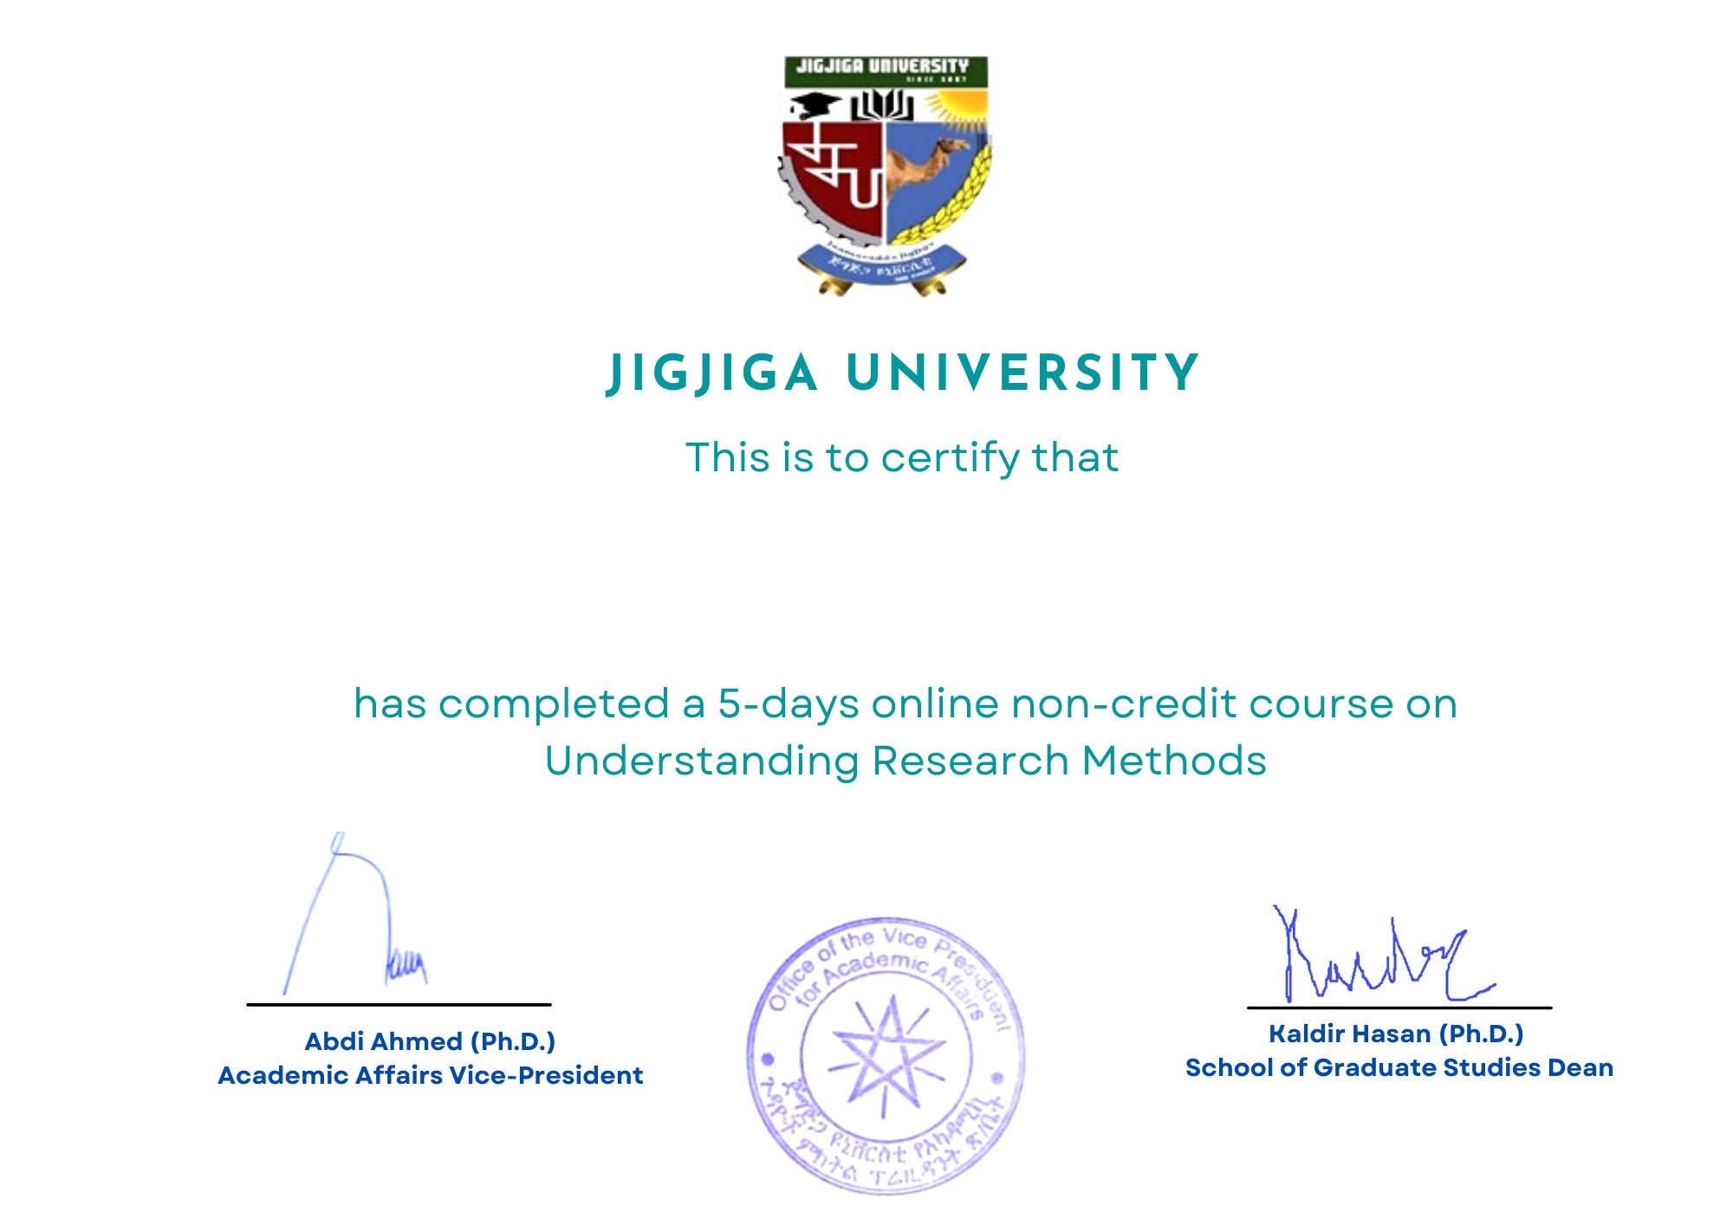

**MOHAMMED ARAB KALIF**